Managing the potential and pitfalls of emerging stem cell therapies
Published:30 Jan 2015 By: Heather Main
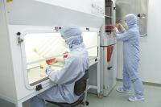
While blood stem cells have been used clinically for over 40 years, it was the discovery of human embryonic stem cells in 1998, that has built expectations for people affected by a multitude of degenerative, chronic and fatal diseases with no cures or effective treatments. The speed with which therapies were expected to roll out of the lab did not take into consideration the complete lack of infrastructure required to make it happen, for many turning potential into frustration. In a recent paper “Managing the potential and pitfalls of emerging stem cell therapies”, Australian stem cell researchers discuss the importance of managing expectations, not only of patients, but researchers, clinicians, investors and governments, and also the need for establishing a pipeline for efficient academic to clinical translation. Here, Heather Main, author of the paper, summarises the key points of the paper highlighting the infrastructure needed to ensure the safe and successful application of stem cells to clinical therapies.

Beware imitators
The biggest threat to stem cell therapies is the currently unregulated commercial markets. These include both autologous treatments, re-injecting a patients own cells to new locations, and allogenic treatments where donor cells are transplanted to patients. While unregulated allogenic commercial treatments are happening in lesser developed countries like China and Turkey, autologous commercial treatments are occurring in developed western countries, including Australia. Vulnerable patients pay $10-100,000 for treatments that have never entered clinical trials, meaning that there is no safety or efficacy data. Cells from all sorts of tissues are being transplanted to all sorts of organs using all sorts of methods and there is no regulation for the ethics or scientific integrity of procedures or the clinical accreditation of practitioners. Not only do these treatments risk patient safety but risk the reputation of stem cell therapies potentially delaying future investment and successes. While there is space for medical innovation, any unproven stem cell treatments at least require independent ethical approval, should never take money from patients and should collect data towards minimizing risks and improving efficacy. Suitable regulation is the first part missing in the infrastructure towards successful stem cell treatments.

Regulated acceleration of stem cell therapies
While regulation is important, it is also possible that it will hold back successful therapies. 2012 Nobel Prize winner, Sir John Gurdon, has criticised the "immense conditions on approval" of autologous cell therapies saying "I think patients would be happy to take the risk of using their own cells given the choice". Further, Dr Christopher Juttner, founder of the allogenic peripheral blood stem cell transplant, is a strong supporter of the medical innovation route by which cellular therapies are clinically tested by physicians, based on sound research. Without such a route he does not believe his, now internationally standard, blood stem cell therapy would have been developed. Even now, the funding required to get cellular therapies through the stages of clinical trial (Figure 1) is largely unrealistic due to expensive protocols and huge risks for investors.

Figure 1: The clinical trials process
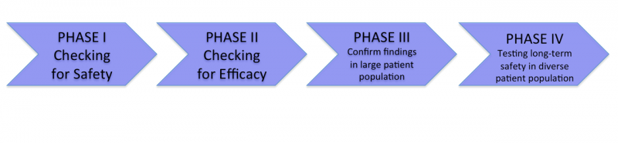
Balancing the under and over regulation of stem cell therapies will require significant investment of time from researchers, clinicians and politicians alike. Some countries are choosing to implement commercial application of stem cell technologies following stage II clinical trials and others developing compassionate exemptions for technologies for those with fatal disorders and no other therapeutic options. These options may lead to acceleration of financial investment in stem cells but not necessarily acceleration of availability of efficacious treatments.

Ticking GMP and financial boxes
In the lab researchers buy in all sorts of reagents to culture their cells, serum from cows, ECM from mice, signaling proteins made in bacteria, all attempts to practically recapitulate the native environment of the cells. Human derived culture conditions are preferred to reduce risks of xenobiotic infections, though the cost and scale of this is not realistic. Human or non-human animal sources, the variability in manufacture processes makes chemically synthesized molecules preferable for clinical culture of cells. Costs, the regulatory restrictions and the need for consistency, are forcing cell-culturing techniques to become chemically defined, replacing complex additives with chemically synthesized alternatives. Successful translation of stem cell therapies is going to mean that the costs are significantly lowered and the processes are standardized and reproducible. Only then can the costs of entering and succeeding the clinical trials process be championed.

Combining expertise for success
Human embryonic stem cells were first made by a developmental biologist, at a university, in 1998. This illustrates how the vast majority of stem cell research occurs, in the absence of clinical experience, in the absence really of a connection to the end goal, the patient. There is a very focused series of milestones required to make an academic achievement into a clinical therapy. No one person has all of the expertise required to move this process from start to finish, making communication and collaboration an essential ingredient of success. Below is an example of what is needed for the idyllic, successful development of stem cell therapy.

Figure 2. Schematic of the development pipeline for stem cell therapies
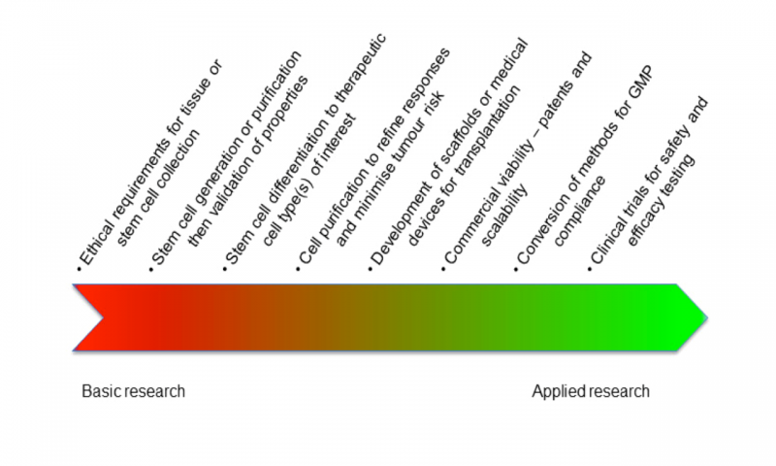
The integration of researchers, clinicians, regulators and investors is required to get through this process successfully and hopefully efficiently. There are so many potential roadblocks it is not a surprise, it’s even amazing, that the first application of embryonic stem cell derived cells in the clinic was in 2010. Just a shame really that the finances of the clinical steps had not been planned properly.

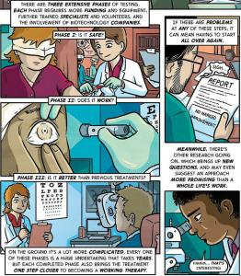Defining pharmaceutical and integrative stem cell therapies

The term ‘stem cell’ is a powerful marketing tool. It carries with it an air of magic, that stem cells are capable of fixing anything. Most researchers are not aware of all of the different types of stem cells and their transplantation behaviour so it is no surprise that patients are not quite clear on the details of treatments they are offered. There are 2 main types of stem cell treatment offered, pharmaceutical and integrative. Pharmaceutical stem cell transplants involve injection of cells for the sake of decreasing inflammation or reverting auto-immune responses. The cells are generally cleared from the body within days or weeks. Integrative stem cell therapies require integration of transplanted cells into the body in order to recover activity of dead or defective cells. Blood stem cell transplantation is an example of an integrative therapy, where defective cells are replaced with healthy cells. The vast majority of stem cell companies and clinical trials to date are based on pharmaceutical stem cell treatments, mainly involving Mesenchymal Stem Cells (MSC). Making the distinction between pharmaceutical and integrative stem cell therapies clear to patients and investors is essential to appropriately distributing support and appropriately distributing disappointment and expectations.

Conclusion
The main question becomes ‘how do we ensure patients are safe while also providing them with the potential to try promising therapeutic technologies’? Should we lighten up on regulation eg. allow commercial sale after Phase II trials, should we offer compassionate exemptions for conditions where no other treatments are available/effective? What we shouldn’t do is just tell patients or parents of patients they have to wait. Stem cells is the little brother to pharmaceutical, biologics and medical device therapies that clinicians and the public are more familiar with. Scientists need to spread the word about their stem cell technologies and listen to the needs of patients and clinicians. Scientists can work more effectively, planning and collaborating to ensure streamlined progression of their technologies from basic research to clinical research to industrial application. Funding can be awarded to collaborative efforts that combine the knowledge base and effective interactions of diverse fields, without the driver of publication. When it comes down to it clinicians are qualified to treat patients and regulatory bodies make the rules. What the scientists need to do is make sure people are informed.

